Assignment 1 – AI Analysis Report
Course: Essentials of AI

Student name: Hira Khan
Registration #: 1453432
Assignment 1 – AI Analysis Report
Pakistani Company Using Artificial Intelligence (AI)
Company: Easypaisa
Part A – Company Profile
Company Name: easypaisa
Founded: 2009
Head Office: Karachi, Pakistan
What the Company Does:
easypaisa is Pakistan's leading digital banking and mobile wallet platform. It allows people to send and receive money, pay utility bills, buy mobile packages, shop online, and perform many banking services using a mobile phone.
Number of Users:
According to easypaisa, it has more than 50 million registered users across Pakistan. 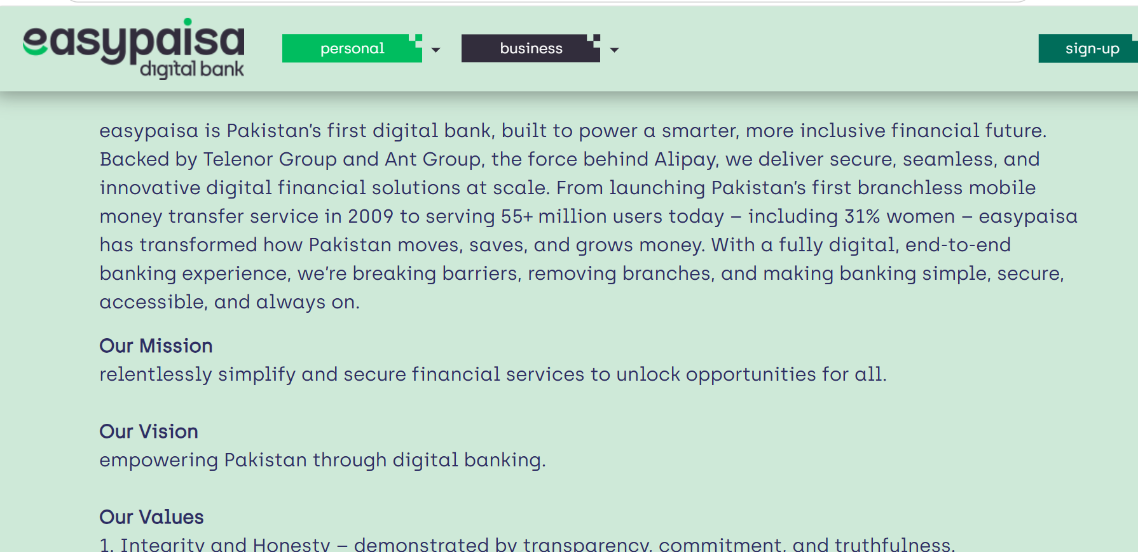
Part B – How They Use AI
Easypaisa uses Artificial Intelligence to improve customer service, detect fraud, manage financial risks, and personalize customer experiences.
Recently, the company launched an AI-powered chatbot called "ello", which provides instant customer support 24 hours a day. The chatbot answers customer questions, guides users through banking services, and reduces waiting time. easypaisa also uses AI in risk management to detect suspicious transactions and improve security. 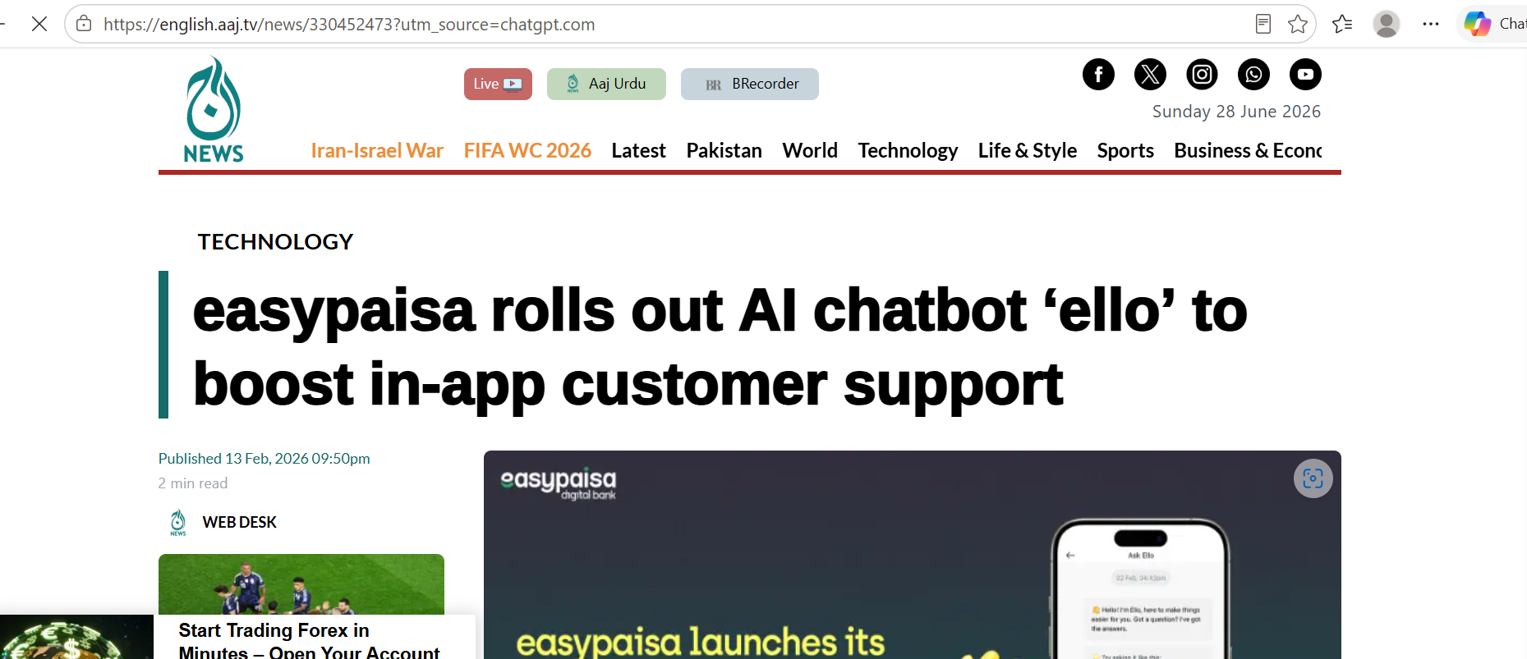
What problem does AI solve?
- Reduces customer waiting time.
- Detects fraudulent transactions.
- Improves customer support.
- Makes banking safer and faster.
What type of data does it use?
The AI system uses:
- Customer transaction history
- Account information
- Customer support questions
- App usage data
- Payment and transfer records
Part C – AI Type Classification
Narrow AI ✔
The AI used by easypaisa performs specific tasks such as customer support and fraud detection. It cannot perform every human task, so it is an example of Narrow AI.
Limited Memory AI ✔
The AI learns from previous customer interactions and transaction data to make better decisions. Because it uses past information to improve its responses, it is also classified as Limited Memory AI.
Part D – Free Tool Experiment
I used Easypaisa website, Aaj English tv website, Associated Press of Pakistan and ChatGPT to research and summarize information about easypaisa.
Part E – My Opinion
Is this AI useful for Pakistan?
Yes. Artificial Intelligence is very useful because it improves banking services and helps more people access financial services safely.
Benefits
- Faster customer support through AI chatbots.
- Better fraud detection and improved banking security.
Risks
- Privacy concerns if customer data is not protected.
- AI systems may sometimes make incorrect decisions or responses.
Suggested Improvement
Easypaisa should continue improving its AI chatbot by supporting more regional languages such as Punjabi, Sindhi, Pashto, and Balochi, so that more Pakistanis can easily use digital banking.
References
- easypaisa Official Website
- AI-powered chatbot announcement. (Aaj English TV)
- AI in risk management and customer experience. (Associated Press of Pakistan)

